Date |  | Venue
Times |  | No of players
Equipment needed |  | Group / ability
Participant needs
Objective
Moment(s) of the Game
Development Pillars being focused on
 | ACTIVITIES: | COACHING POINTS | DIFFERENTATION
WARM-UP |  |  |  | 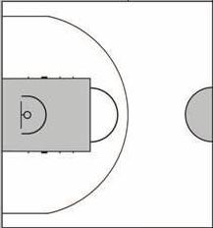
MAIN CONTENT:

COOL DOWN / SUMMARY:

‘What’
What happened?
What feedback did you receive from others?
What were the strengths of the session?
How was the session objective met?
‘So What’
So what does this tell me? What could I have done differently?
‘Now what’?
Now what needs to happen in the next session, what do I need to do more of and less of?

